**Development and characterization of Silicon Carbide based composites**

**A MAJOR PROJECT REPORT**

*Submitted in partial fulfilment of the*

*requirement for the award of the degree of*

**BACHELOR OF TECHNOLOGY**

**IN**

**METALLURGICAL AND MATERIALS ENGINEERING**

**By:**

**RAVI SHANKAR YADAV (13118072)**

**SETH RIDDHEISH ANILKUMAR (13118080)**

****

****

**DEPARTMENT OF METALLURGICAL AND MATERIALS ENGINEERING**

**INDIAN INSTITUTE OF TECHNOLOGY ROORKEE**

**ROORKEE – 247667 (INDIA)**

**APRIL, 2017**

**CERTIFICATE**

This is to certify that the project entitled ― **Development and characterization of Silicon Carbide based composites** in partial fulfilment of the requirements for the award of the degree of Bachelor of Technology in Metallurgical & Materials Engineering, and submitted in the Department of Metallurgical & Materials Engineering of Indian Institute of Technology, Roorkee, India, is an authentic record of our own work carried out during the period from July 2016 to April 2017, under our supervision and guidance.

DATE: 16th April

PLACE: Roorkee

**DR. B. VENKATA MANOJ KUMAR**

Associate Professor

Department of Metallurgical & Materials Engineering

Indian Institute of Technology,

Roorkee - 247667

**ACKNOWLEDGEMENT**

We express our sincere gratitude to each and every one who has helped me in completion of this project. First of all, we offer a sincere thanks to Almighty, for always being with us through thick and thin. I also thank my parents who have been constant moral supports throughout.

I feel immense pleasure and privilege to express my deep sense of gratitude, indebtedness and thankfulness towards my mentor, **DR. B. VENKATA MANOJ KUMAR**, Associate Professor, Department of Metallurgical & Materials Engineering for motivating us with constant appreciation and appraisal.

I express sincere thanks towards **DR. B. VENKATA MANOJ KUMAR**, for co-coordinating this project throughout the year. I would also thank my Institution and entire staff of Central Library, IIT Roorkee who provided me with facilities for various books, research papers and internet.

I shall remain ever grateful to all the persons, who have helped, inspired and encouraged me and above all made me an ever more learned person.

Last but not least, I would like to convey my heartfelt thanks to my friends and fellow mates who have directly or indirectly helped me in the compilation of this report.

**ABSTRACT**

Title of Report: Effect of additive (Titanium CarboNitride) on phase evolution of Silicon Carbide (SiC) composites prepared by Spark Plasma Sintering. Prepared SiC composite with densification greater than 96% and with improved mechanical properties than monolithic SiC.

Silicon carbide is a high-performing non-oxide ceramic, and has considerable industrial importance. Silicon carbide (SiC) ceramics exhibit excellent heat-resistance, creep-resistance, wear-resistance, acid-resistance and corrosion resistance properties and then can be applied as the structural components under extreme environments [1-5]. Covalent SiC powder compacts are difficult to densify; therefore, the sintering additives, such as B–C co-doping, are usually used for its densification [6–10].

Monolithic silicon carbide can be densified only up to a certain extent; beyond that grain coarsening begins to take place. In this study this composite was fabricated using β-SiC and TiCN powder. We aim to achieve a densification greater than 96% for which we apply composite approach with TiCN (Titanium CarboNitride) as one of the phases with 0 vol%, 10 vol%, 35 vol% & 50 vol%. Relative densities of >= 98% were achieved for the composite SiC-TiC0.5N0.5. Thermal and mechanical properties investigated showed an increment in thermal conductivity, flexural strength and fracture toughness of the SiC ceramic.

From the SEM and XRD studies presence of any Other phase will be investigated in the final sintered sample. These properties were favorable only up to a certain range of the additive, beyond that both the thermal and mechanical properties deteriorated. Overall the composite was to exhibit superior mechanical properties compared to monolithic Silicon Carbide and Titanium Carbide.

TABLE OF CONTENTS:

1. Introduction ……………….(6)
2. Literature Review ……………….(8)
   1. Prior studies on phase evaluation of monolithic Silicon Carbide ……… (8)
   2. Prior studies on phase evaluation of Silicon Carbide with additives ...(10)
   3. Thermal and Mechanical Properties of TiC0.5N0.5Composites ……………(11)
3. Work Plan ………………….(13)
   1. Powder milling …………………(13)
   2. Silicon carbide mixing with TiCN ………………….(13)
   3. Phase evaluation by Powdered XRD …………………(14)
   4. Density calculation ………………….(14)
   5. Calculations for weight of different samples ………………….(15)
4. Experimental Procedure ………………….(17)
5. Discussion ………………..(20)
   1. Batch 1: Monolithic SiC ………………..(22)
   2. Batch 2: Composite of 10 % TiCN with SiC ……………………(25)
   3. Batch 3: Composite of 35 % TiCN with SiC …………………(28)
   4. Batch 4: Composite of 50 % TiCN with SiC …………………(32)
6. Results .……………...(36)
7. Conclusion …………………(37)
8. Bibliography ...……………..(38)

**INTRODUCTION**

The previous analysis on sintering of monolithic silicon carbide showed that densification of about 98% took place at a temperature of 1950oC. This was achieved by conventional hot pressing sintering, which simply heats the material in the presence of an applied pressure. Why this process is not widely preferred is due to problem of grain coarsening and this leads to decline in mechanical properties 1,2. Spark plasma sintering has also been carried out to achieve greater densification but the problem of grain coarsening persists in it. One of the major drawbacks by these processes was, greater densification was obtained but at such a high temperature sufficient grain coarsening took place. These larger grains led to a fall in the mechanical properties of the developed ceramic3.

To overcome this large number of additives have been tried. Each of them have been tried so that it could lower the sintering temperature by providing a liquid phase in the medium. Enhancement in densification was observed along with an improvement in mechanical properties.

Additives improved densification by:

a) Formation of a liquid phase to fill the pores,

b) quick necking between two particles.

To deal with our problem TiCN (Titanium Carbonitride) is being used in SiC composite. This composite was fabricated using β-SiC and TiN powder.We desire that sintering successfully leads to >=96% densification at lower temperature and pressure than before. Along with it the thermal and electrical conductivity of the composite may show enhancement. Flexural strength and fracture toughness are also expected to increase.

TiCN has some excellent properties such as thermal conductivity, toughness and wear resistance4,5. Thus when combined with SiC it can really form a composite which can have application in areas where both electrical, thermal and mechanical properties are required together. One of the major problems above was that the sintering was carried out by conventional methods. These have certain drawbacks:

* Slow heating and cooling rate resulting in grain coarsening.
* Binder was mixed which resulted in a reduction of mechanical properties.
* Sintering time was more than Spark Plasma process.

Thus to overcome these drawbacks, sintering of SiC composite will be carried out by Spark Plasma Sintering process, owing to its fast sintering time and many other advantages. In this process the sintering temperature will be in the range of 1700o-1800oC and for very short sintering time i.e. 5-10 mins.

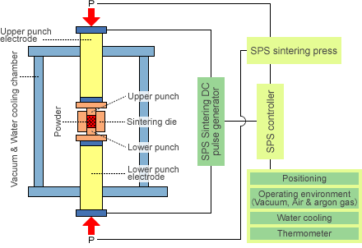

**Figure 1(a) indicating SPS apparatus Figure 1(b) indicating process of SPS.**

**Characteristics of Spark Plasma Sintering:**

The main characteristic of SPS is that the pulsed [DC current](https://en.wikipedia.org/wiki/Direct_current) directly passes through the [graphite](https://en.wikipedia.org/wiki/Graphite) die, as well as the powder compact, in case of [conductive](https://en.wikipedia.org/wiki/Electrical_conductivity) samples. [Joule heating](https://en.wikipedia.org/wiki/Joule_heating) has been found to play a dominant role in the densification of powder compacts, which in turn results in achieving near theoretical density at lower sintering temperatures compared to conventional sintering techniques.

Sintering time required is also much less than for other methods, so SPS is the process used in this experiment. The general speed of the process ensures it has the potential of densifying powders with nanosize or nanostructure while avoiding coarsening which accompanies standard densification routes.

**Why we use pulsed DC :**

By using pulsed DC we get the benefits such as localized heating, enhanced diffusion, faster neck growth in a very short time and almost 100% densification.

Enhancement in rate of diffusion is a dominant reason for using pulsed DC,along with quick neck forming. Improved diffusion is needed in this case, as SiC composite is being sintered,and Si-C bond is upto 88% covalent so atomic diffusivity needs considerable enhancement[11].

**Dynamics of Spark Plasma Sintering and the effect of pulsed DC**

* Electric discharge is generated across the capacitors’ gap, and thus surface oxide films are pierced beyond a certain voltage level called breakdown voltage and electrical breakdown of dielectric film on powder particle.
* This electric discharge around contact generates plasma that is ionized gas between the powder particles.
* Surface activation results in clean grain boundary. This shows direct grain-to-grain contact which is attributed to the physical activation of powder particles.

**LITERATURE REVIEW**

In this study silicon carbide composite prepared with β-SiC and Titanium Carbo-Nitride for improved mechanical properties at elevated temperature. The three main aspects to be considered in this literature review are the characterization (phase evolution and microstructure), densification and mechanical properties.

* **Prior studies on phase evaluation of monolithic Silicon Carbide:**

**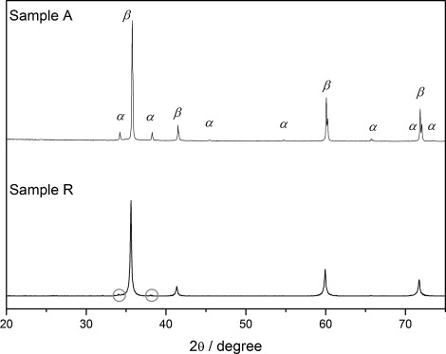**Monolithic Silicon carbide sample is prepared with sintering of annealed (300◦C for 3h.) granulated β-SiC powder and compared to reference sample of β-SiC.

Table 1:Phase comparison for sintering process

Sample A- annealed (300 ◦C for 3h.) granulated SiC powder.

|  |  |  |
| --- | --- | --- |
| Phases | Before sintering | After sintering |
| Major phase | β-SiC (3C) | β-SiC (3C) |
| Minor phase | - | α-SiC (6H) α-SiC (4H) |
| Trace | Graphite α-SiC (6H) | Graphite |

Fig.2 -. XRD pattern of annealed sample A and reference Sample R(raw β-SiC) , showing the presence of β-SiC, α-SiC .

We can conclude following points form the study6:

* After densification platelet shape of SiC grains.
* The partial transformation of β-SiC at 1850◦C .
* The β-/α-SiC ratio of approx. 73/27.
* Fully dense-SiC ceramics ~99.9% (3.2 g/cm3).

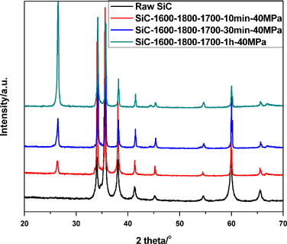Another study was done on monolithic silicon carbide in which three step spark plasma sintering was done.

Phase identification –

* Raw powder hexagonal 6H-SiC crystal parameters deviated corresponding to the 5H-SiC structure.
* Shift in cell parameters indicates that shrinkage occurs.
* Density increase with dwell time.

Fig. 3 XRD patterns of the sintered SiC ceramics as well as the raw SiC powder.

* **Prior studies on phase evaluation of Silicon Carbide with additives:**
* **SiC with AIN and Y2O3**

A globular grained microstructure was obtained from α-SiC powder. Mixture of β-SiC, with a small amount of α-SiC seeds was found in sintered sample, revealed platelet shaped grains with an aspect ratio of eight.

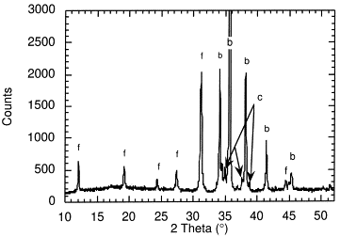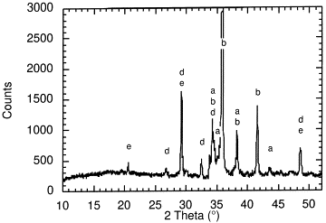

Fig 4(b). Diffractograph of a sintered and annealed α-/β-SiC powder mixture derived material.

Fig 4(a). Diffractograph of a sintered pure α-SiC powder derived material.

* **β-SiC with Al203 additions:**



* Theoretical density 98% with Al203 at 2050°C for 30 min in liquid-phase sintering.
* 50% of the β-phase was transformed to the α-phase.
* Al203 addition above 12-15 wt% no significant increase in density.

Phase transformation from to β to α-SiC reveals a dependency on the initial content of β-SiC and the sintering atmosphere.

The transformation is completely supressed for pure β-SiC starting powders when the additive system consists of 10.34 wt % Y2O3 and 2.95 wt % AlN.

* The phase transformation kinetics was studied with a powder mixture having a α/β- SiC ratio of 1 : 9; the additive content was 10.34 wt % Y2O3 and 2.95 wt % AlN.

The α/β-mixture shows an increasing phase transformation from β-SiC to α-SiC with sintering time as indicated by the increasing intensity for the 6H/4H-peaks8,9.

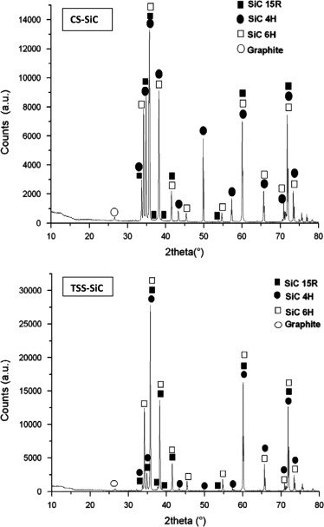From the results it could be concluded that a significant change of the grain morphology could be obtained in the presence of a phase transformation, whereas pure α-SiC or β-SiC did not transform with the standard additive system.

* **SiC with B and C**
* α-SiC with sintering aids boron and carbon.
* TSS-SiC was obtained at 2050 °C and showed finer microstructure than CS-SiC fired at 2200 °C.
* TSS-SiC was densified (97.7%T.D.) at 2050 ◦C instead of 2200 ◦C needed for CS-SiC (97%T.D.).

Fig. 5. XRD spectra of of CS-SiC and TSS-SiC materials.

Phases present in sintered sample:

|  |  |  |  |
| --- | --- | --- | --- |
| Material | 6H (%) | 4H (%) | 15R (%) |
| CS-SiC | 26.4 | 23.0 | 50.6 |
| TSS-SiC | 84.7 | 10.0 | 5.3 |

Table 2:Phase comparison of different Si forms

* **Thermal and Mechanical Properties of TiC0.5N0.5Composites**

This review has an analysis on addition of TiN to SiC matrix, with various additives also involved for ease of sintering, and its consequences on properties of SiC.

The TiN added to the SiC matrix generally reacts with SiC and/or sintering additives during sintering and forms second phase(s). The following are suggested reactions in the SiC–TiN composites during sintering:

$TiN+2B→TiB_{2}+0.5N_{2}$….(1)

$4TiN+7SiC+4 Al_{2}O_{3}→4TiC+4 AlN+7SiO↑ +3CO↑ +2Al_{2}O$….(2)

$TiN+2SiC+3Y_{2}O_{3}→TiC+2SiO↑ +6YO↑ +CO↑$….(3)

$4TiN+2SiC →4TiC_{0.5}N_{0.5}+2Si_{liq}+ N_{2}↑$....(4)

The B, Al2O3, and Y2O3 in Reactions (1)–(4) were added as sintering additives, and they reacted with TiN and SiC to yield TiB2, TiC, or AlN.

A small amount of TiN added into liquid-phase sintered SiC ceramics enhanced densification and improved mechanical properties [5]. In this work, the effect of initial TiN content on the thermal and mechanical properties of SiC–TiC(1–x)Nx with x = ~0.5 (hereafter TiC0.5N0.5) composites was investigated.

The relative density of a monolithic SiC sample (STN0) fabricated from sub micrometer-size b-SiC and 2 vol% Y2O3–Sc2O3 additives was 98.9%. All the other specimens containing TiN could be densified to ≥ 99.3% when hot-pressed at 2000°C for 3 h under 40 MPa in a nitrogen atmosphere. This result suggests that the addition of TiN is beneficial in densification of SiC– TiC0.5N0.5 composites7.

Figure shows XRD patterns of the TiN-added SiC specimens. The specimens consisted of β-SiC (3C) only for TiN content up to 2 vol%. The XRD patterns exhibited new peaks (marked by dots in Fig.) along with β-SiC peaks for the specimens with TiN content of 10 vol% (STN10) and higher. New peaks for the STN10, STN20, and STN35 specimens fit well with TiC(1–*x*)N*x* peaks. The calculated lattice parameters of TiC(1–*x*)N*x* are 0.42863 nm and 0.42859 nm for the STN20 and STN35, respectively. Both values are almost same with the lattice parameter (0.42860 nm) of TiC0.5N0.5.XRD results suggest that (1) TiN particles transformed to a 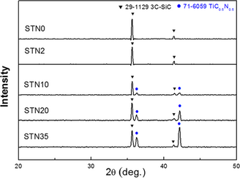TiC0.5N0.5phase during the sintering process by combining with carbon atoms from neighboring β-SiC particles and (2) the β→α phase transformation of SiC was completely suppressed during hot pressing.

Figure 6: XRD patterns of monolithic SiC and SiC-based composites sintered with 2–35 vol% TiN.

**WORK PLAN**

This experiment is studying a composite that was fabricated using β-SiC and TiCN powder.

Formation of SiC-TiC0.5N0.5 composite basically involves the sintering of Silicon Carbide powder mixed with Titanium Carbonitride. The formation of this composite does not involve only one step, however a number of sub-stages define its formation.

The experimental procedure followed is a slight modification of that followed in Literature Review. β-SiC of size initially 40µm was first milled in ball milling and goes to size less than 5 µm mixed with TiCN of size 2-3µm. After some reactions involving the two species formation of SiC-TiC0.7N0.3 and SiC-TiC0.3N0.7 composite takes place for different composition of TiCN addition.

To carry out the process of sintering a number of pre-processing steps are to be followed before the final testing of mechanical properties can be done. Thus the process involved in the fabrication and evaluation of Silicon Carbide –Titanium Carbonitride composite is:

To carry out the process of sintering a number of pre-processing steps are to be followed before the final testing of mechanical properties can be done. Thus the process involved in the fabrication and evaluation of Silicon Carbide –Titanium Carbonitride composite is:

* **Powder preparation:** A process that involves the mixing of different powders in exact amount i.e by maintaining a constant volume fraction of the two powders. This process involves two sub-stages:

1. **Powder Milling:** It involves milling for size reduction of the two powders balls in a bottle/jar for about 60 hours depending on the hardness.
2. **Powder Mixing:** A process that involves the mixing of different powders in exact amount i.e. by maintaining a constant volume fraction of the two powders. After milling, mixing will be continued for about 12 hours at a speed of 125 rpm. It is one of the most important steps in sintering as any contamination or error in this step gets carried forward till all stages of sintering are complete and the presence of contamination deteriorates the final composite. This process was planned to involve two sub-stages:

During the ball milling a small amount (0.5-1 mg) is taken out and X-Ray diffraction and SEM analysis is carried out. This is done after shifts of every 2-3 hours to ensure thorough mixing and to check whether the powders are free from contamination or not. Care is to be taken to avoid very large size reduction.

* **Pre-sintering Sample Data compilation:** Exact size of powder before sintering is found out at this stage, and also it is checked if mixing is thorough enough. If yes, sintering is carried out. If not, the powder mixing step is repeated.
* **Sintering:** One of the important parameters in sintering are the sintering time and temperature. Spark Plasma sintering is carried out here with a temperature of about 1800oC. This process is to be carried out in an Argon atmosphere with a pressure of 50 atm to be applied by the die and punch. Sintering time will be 5 min to avoid excessive grain growth. Final densification to be achieved is supposed to be greater than 96%.
* **DENSITY EVALUATION AND COMPARISON WITH CALCULATED VALUES:** Here, we compare with theoretical values, which is what we would expect, and see the actual value after carrying out tests based on relative density.
* **Microstructural analysis:** After the formation of pellets, their microstructural evaluation is to be carried out. This is done by the following methods

1. Scanning Electron Microscopy and
2. EDS.

It also helps to examine the conversion of β-SiC to α-SiC. Proper etching is to be carried out to examine the grain morphology of the formed composite.

Etchant such as Hydrofluoric acid is used, or thermal etching at 160o C can also be done.

Phase evolution of different phases present is to be carried out by X-Ray diffraction.

Presence of any third phase or lattice constant can be easily determined by this method.

If after etching also the surface morphology is not clear then the sample is to be broken and then the fractograph is to be taken out to examine the structure of the fractured part.

* **Mechanical and Thermal properties Evaluation:** After the pellet formation, the final stage is the evaluation of its mechanical properties. The different mechanical properties to be evaluated are flexural strength, fracture toughness, elastic modulus and hardness.

To evaluate the hardness of the pellet micro-indenter is used since these are very hard ceramics and thus normal indenter might not work properly.

Thermal properties are done by gradual heating and checking dimensions of pellet. Heating must be gradual as pellets made from ceramics can crack.We determine coefficients of linear, surface and volumetric expansion in this manner.

* **Compilation of Results across all sets of samples, followed by inferences and conclusion to experiment.**
* **Calculations for weight required for SiC and TiCN for Different Samples :**

SiC-based ceramics have been known as materials which have high strength and excellent wear resistance observed at high temperatures; but, they exhibit poor reliability due to low fracture toughness. Thus incorporating it with some additive could solve the above problem. Among this one of the additives is TiCN. Our aim is the fabrication of SiC-TiC0.5N0.5 composite. The specification of the pellet formed will be 10 mm in diameter with 4-5 mm in height. Depending upon the volume fraction of different elements such as Silicon Carbide and Titanium-Carbonitride, different weight of such compounds will be taken to form the pellet. The given diagram shows the dimensions of the pellet formed.

10mm

4mm

4mm

The volume fraction of TiCN was 0%, 10%, 35% & 50%. Corresponding to it we will have different weight %. Thus from here we can find out that to make a pellet of such dimension what will be the weight of the two compounds.

**Calculation:**

Density of SiC: 3.21g/cc, Density of TiCN: 5.05g/cc

Volume of the pellet: πr2h = 3.14 \* 0.5\*0.5\*0.4

=0.314 cm3

Therefore, mass = density \* volume

1. For 0% TiCN,

M=D\*V;

=3.21\*0.314 = 1.00794 g

1. For 10% TiCN

MSiC= 3.21\*(0.314\*0.90) = 0.907146 g

MTiCN= 5.08\*(0.314\*0.10) = 0.159512 g

1. For 35% TiCN

MSiC= 3.21\*(0.314\*0.65) = 0.655161g

MTiCN = 5.08\*(0.314\*0.35) = 0.558292g

1. For 50% TiCN

MSiC= 3.21\*(0.314\*0.50) =0.50397g

MTiCN= 5.08\*(0.314\*0.50) = 0.79756g

During all these process of powder mixing, ball milling and sintering we have to take into account the error or the weight loss. So to compensate for that we will take 20% extra weight of both the compounds.

The given table 3.1 shows the volume and weight fraction of the two compounds.Calculations have been made previously before compiling the table.

Table 3:Weight of components in all batches of SiC composites

|  |  |  |  |  |  |
| --- | --- | --- | --- | --- | --- |
| **Silicon Carbide** | | | **Titanium Carbonitride** | | |
| Vol% | Weight(g) | Weight +20% included | Vol% | Weight(g) | Weight +20% included |
| 100% | 1.00794 | 1.209528 | 0% | 0 | 0 |
| 90% | 0.907146 | 1.0885752 | 10% | 0.159512 | 0.1914144 |
| 65% | 0.655161 | 0.7861932 | 35% | 0.558292 | 0.6699504 |
| 50% | 0.50397 | 0.604764 | 50% | 0.79756 | 0.957072 |

**EXPERIMENTAL PROCEDURE**

Silicon carbide based ceramics have been known as materials which have high strength and excellent wear resistance observed at high temperatures but they exhibit poor reliability due to low fracture toughness. Thus incorporating it with some additive could solve the above problem. This Study aims to develop SiC-TiCN Composites of varying composition. They have pellet of size diameter=10mm, thickness=4mm.

**Powder preparation:**

* Commercial β-SiC powder (99% purity) of size 37 μm was available.
* Initial Size of powder is too large for sintering.

Why do we need size reduction of silicon carbide Powder?

* Lesser particle size provides larger surface area overall, so when dc pulsed current is passed there will be more surface activation energy. Consequently, there is better necking and better sintered sample is obtained.
* If particle size is very less (i.e. 5µm or less) chances of presence of internal porosity will be less. Moreover during sintering, when the particles joins to form a single grain, coarsening of formed grain will be less.
* Superior microstructure, which is what is desired, is obtained for smaller sizes.
* Thermodynamics of process favoured for smaller size-system moves in direction of increasing entropy. At holding temperature,for the same volume, process is having more entropy for a large collection of smaller volume particles than for a small collection of larger volume particles.

**Powder Milling Parameters:-**

• Wet ball milling of initial powder carried out in Retsch PM-100.

• Powder to ball ratio was 1:10.

• Rotation speed was 200 rpm with direction reversal.

• Total milling time was 62 hours owing to the hardness of Silicon Carbide.

For size reduction process wet ball milling is used. Toluene is used as wetting agent because it does not have OH group so lesser chances of samples to get oxidized. In this weight of powder is used is 20 g (25 g has been taken into account in case any losses happens during experiment). The tungsten carbide balls used for ball milling weigh 7.6 gm each. Total 33 balls of tungsten carbide are being used to make powder to ball ratio 1:10. Total time taken for this process was around 62 hours and this was carried out in 10 sittings. Each sitting was a continuous process of 7 hours and then toluene was added to make sure wet milling continuous. The rotation speed was 200 rpm. If rotation speed increases, then there will be a lot of heat production which will lead to oxidation of sample.

**SPARK PLASMA SINTERING PROCESS FOR SAMPLES:**

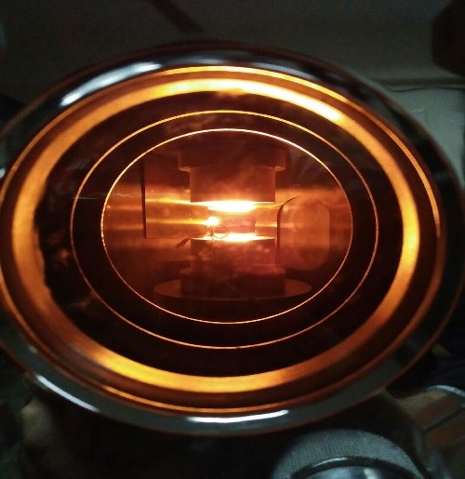Spark plasma sintering process is used because the high sintering rate is possible in SPS since heating and cooling rate is very high. Also, sintering time is reduced in SPS due to small holding time at sintering temperature, usually 5 to 10 minutes. So Simultaneous application of elevated temperature and pressure leads to high densification and hence a dense compact at sintering temperatures lower by 200 to 250°C than in other sintering methods is easily obtained. In SPS, since no coarsening and grain growth were allowed to occur, high relative densities were reached in very short time.

In SPS the powder is directly fed into the graphite dies and the die is enclosed with suitable punches. This entire assembly is directly put into the SPS chamber and spacers are used. The chamber is now closed and the atmosphere (Argon) in which sintering is to be carried out is applied in the chamber. The program has set into the control unit and sintering is carried out. Parameters are as given in Table 3.2 .

Table 3.2: Parameters of SPS for both batches of sample were exactly the same, yet **current at sintering temperature was different due to different composition**.

|  |  |  |  |  |
| --- | --- | --- | --- | --- |
| **Parameter** | **Pure SiC** | **90% SiC with 10% TiCN** | **65% SiC with 35% TiCN** | **50% SiC with 50% TiCN** |
| Total Time | 58 min | 58 min | 58 min | 58 min |
| Holding time | 5 min | 5 min | 5 min | 5 min |
| Voltage | 5 V | 5 V | 5 V | 5 V |
| Heating rate | 100 °C/min | 100 °C/min | 100 °C/min | 100 °C/min |
| Sintering temp. | 1800 °C | 1800 °C | 1800 °C | 1800 °C |
| Cooling time | 38 min | 38 min | 38 min | 38 min |
| Load on Die | 3.6 kN | 3.6 kN | 3.6 kN | 3.6 kN |

Table 4:Spark Plasma Sintering parameters table for all samples

**Sintering profile for monolithic SiC:**

**Figure 7:Graphs indicating various parameters of sintering throughout duration of SPS for monolithic SiC.**

**OBSERVATIONS:**

* Contamination of Tungten via milling balls and jar need to be accounted for and if possible,prevented.Prevention not possible,so we take this to be an SiC-W + TiCN composite and account for properties accordingly.
* Density computing needs to be done keeping into account non-stoichiometric mixing and presence of impurities for comparison to be valid.
* Addition of TiCN has led to improved electrical conductivity of composite. This in turn makes process of SPS as sintering techniques for SiC-TiCN composites even more attractive, as improved conductivity improves SPS as it uses Pulsed DC and electrical discharge causes surface activation leading to cleaner grain boundary and prevention of coarsening. This will lead to better densification.

**Figure 8:Comparative plot of required current for SPS of samples of monolithic SiC and SiC-10%TiCN composite**

Comparative plot leads to one observation regarding major difference between Current vs Time. **Current magnitude at holding temperature throughout holding time is significantly lower for pure SiC vs SiC with 10% TiCN.** This is due to superior conductivity as Ti+ ions present at point of sintering lead to enhanced conductivity.

**DISCUSSION**

**Batch 1- Monolithic Silicon Carbide:**

For the first composition we have to prepare pure Silicon carbide pellet. So we need to take powder of silicon carbide directly form milled SiC powder which have size less than 5µm. reduced sized SiC powder prepared from milled powder by heating powder at 150°C for four hours after this the powder was died and sieved for further characterization.

* **Powder Analysis:**

On analysis of plot, we saw 91.8% vol SiC present, rest was WC impurity which we conclude got added on milling stage. The list of peaks will confirm our data, which will be further discussed comparatively.

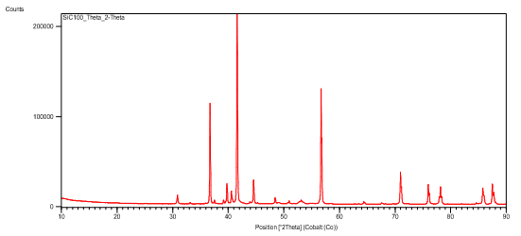

**Figure 9: XRD profile for monolithic SiC**

We also noted presence of Silicon Nitride, besides noting that SiC phase evolved in final sample was present in both 6H and 8H forms. We started with β-SiC so this phase evolution is of particular interest. We also note that the WC has formed a solid solution, the only plausible explanation for SiC and WC both showing peaks of 100% intensity at 41.617°.

Other present phases included non-stoichiometric compounds of W,C and N, which will have impact on density calculation, both experimental and theoretical. To explain their presence, we are checking available values to compute their bond strength and determine if this was a factor in their formation.

* **SEM analysis**:The size of the powder after milling was confirmed by Scanning Electron Microscopy. With a magnification of 5000x and 10000x the following images of the powder were taken. On a scale of 10 μm almost all the particles are less than 5 μm. Thus ensuring better compaction and proper sintering with greater surface area. The variation in contrast shows the presence of different phases formed during the milling process.

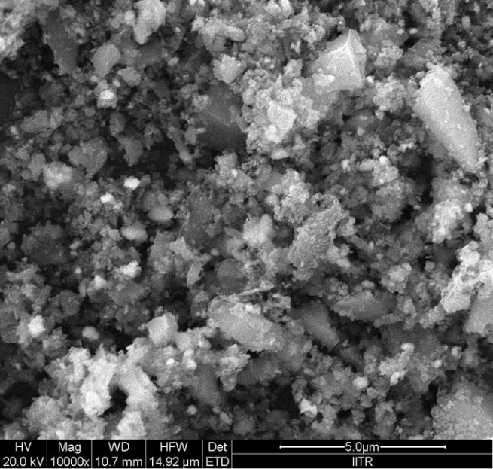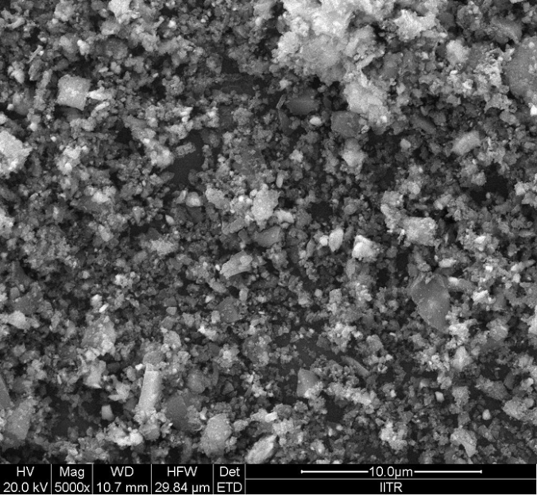

**Fig 10:** SEM images of Pure SiC. Variation in colour indicates presence of phases other than SiC taken. Lighter colouration indicates WC-rich portion, darker colour indicates SiC-rich portion. Verified by taking EDS of spot in region.

* **EDS Analysis :**From the analysis as well as the microstructure photographs, we learnt the following:
* Light and dark colouration implies presence of different phases in the sample.

For darker region, major phase-SiC, minor phases-small %SiO2 and other compounds, including Tungsten compounds. WC is present in enough amount so consider it as additive. In lighter coloured region, converse is true.

* Major elements present-C,Si,W

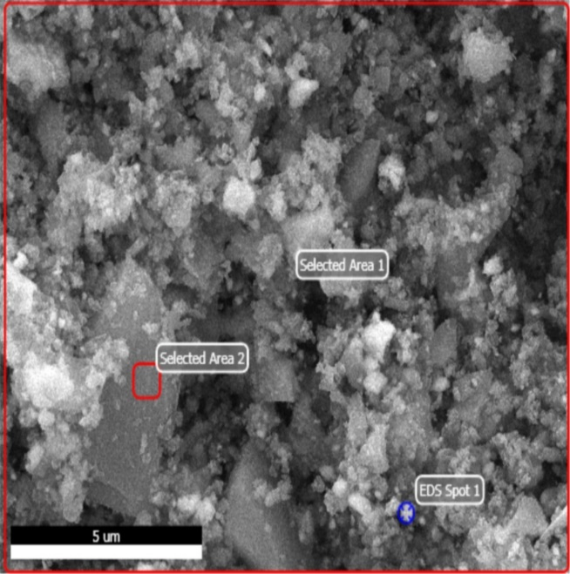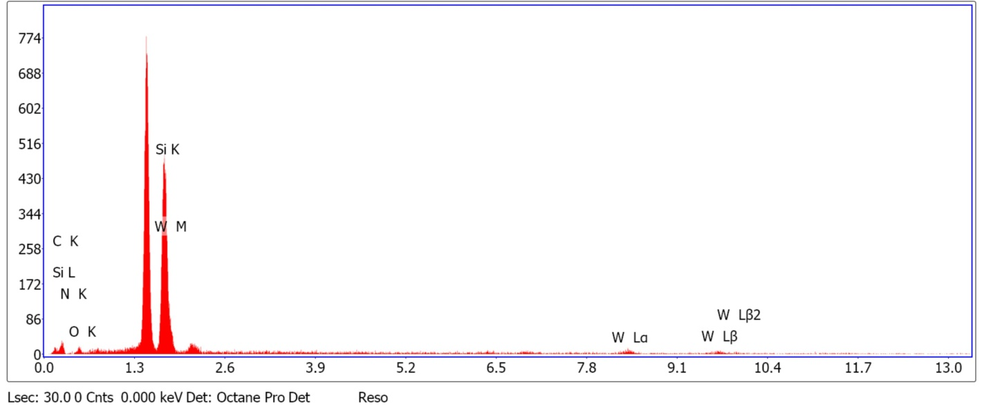**Fig 11 : EDS Peaks for batch 1**

|  |  |  |  |  |
| --- | --- | --- | --- | --- |
| **EDS DATA- Pure SiC-whole sample(Selected Area 1)** | | | | |
| Element | Weight% | Atomic% | Net int. | Error % |
| C K-line | 37.09 | 68.08 | 8.27 | 17.87 |
| N K-line | 0.29 | 0.77 | 0.06 | 99.99 |
| O K-line | 7.22 | 9.95 | 3.20 | 33.27 |
| Si K-line | 32.14 | 17.22 | 81.21 | 4.65 |
| W L-line | 23.26 | 3.99 | 7.59 | 41.33 |

**Figure 12**

**Table 5 :Elements in batch 1:**

**DENSITY CALCULATIONS:**

The density of the pellet formed during SPS was measured using Archimedes principle. The mas of the pellet were measured using electronic beam balance.

Mass in air – 0.8615 g

Mass in Water –0.6568 g

Experimental Density: (Ma)/ (Ma – Mw) \* ρw

: **4.2087 g/cc**

Expected Theoretical density of pure SiC: **3.21 g/cc**

**Conclusions:**

* Theoretical density, after accounting for presence of W, oxides of W,SiO2 and other reaction products is now calculated using rule of mixtures.Tungsten as an impurity must have been added during milling and from jar.
* Corrected theoretical density,based on elemental weights as seen in EDS,and taking error % given in EDS table into account, is 3.65 g/cc.
* This does not take into account stoichiometric compounds like WO2,WO3 etc as EDS only gives elemental peaks.
* **Accounting for stoichiometric mixing and compound formation, density computed is 4.33 g/cc, very close to experimental value of 4.167 g/cc in case of pure SiC.**
* **%densification obtained=97.2%**

**Batch 2- Silicon Carbide with 10 Volume % TiCN:**

For the second composition we have to mix the two powders in the same ball milling machine. Since we are mixing the two powders the parameters for mixing have to be changed. Titanium carbonitride was commercially available of size less than 5μm. Thus we only had to mix it with the previously milled SiC powder. Toluene was used in a much higher amount to ensure homogeneous mixing. The other parameters were.

* Rotation speed of 125 Rpm with a milling time of 12 hours.
* Large amount of toluene was for proper mixing.

After material characterisation via X-ray diffraction, we did spark plasma sintering (SPS).

This sample set also showed many phases, but almost all were as expected, with TiC and TiCN both formed. TiCN showing non-stoichiometric ratio of C=0.7 and N=0.3. We believe it is due to larger amount of present C during SPS stage, where Ti+ ions have greater pulling power over C atoms due to ionic behavior and stronger Ti-C bond vs Si-C bond. SiC existed in two forms, rhombohedral and 6H as from batch 1 pure SiC.W,C and N compounds existed here too, with density variation expected here as well.

1. **XRD analysis:** Information provided by XRD analysis is same as pure Silicon carbide, except that peaks of Ti compounds, chiefly TiCN are also present. Tungsten compounds are indicated here too, indicating contamination in this batch too, via milling balls and jar.

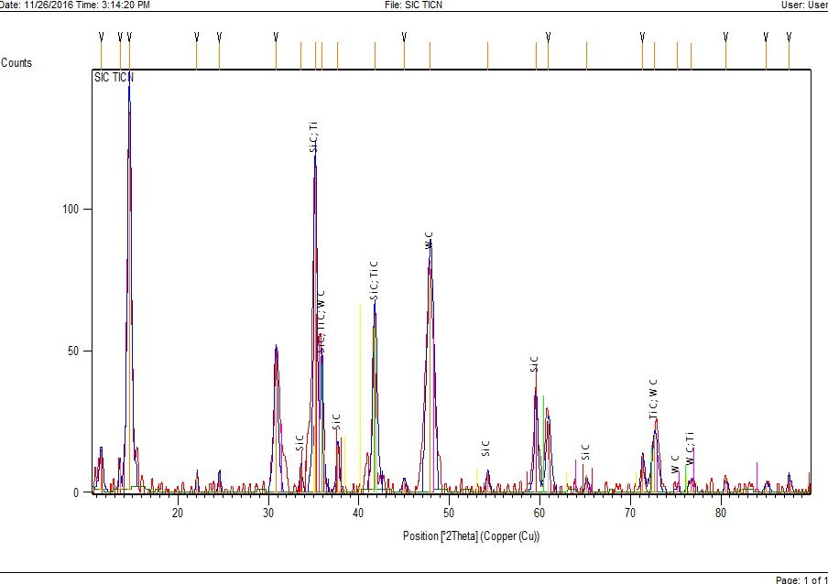

**Figure 13:XRD pattern showing overlapping peaks of SiC with TiC.**

1. **SEM analysis:** SEM analysis was carried out for size of the particles and Elemental composition. The given images of SiC-TiCN powder reveals the size of the particles almost less than 5 micron ensuring a good densification.

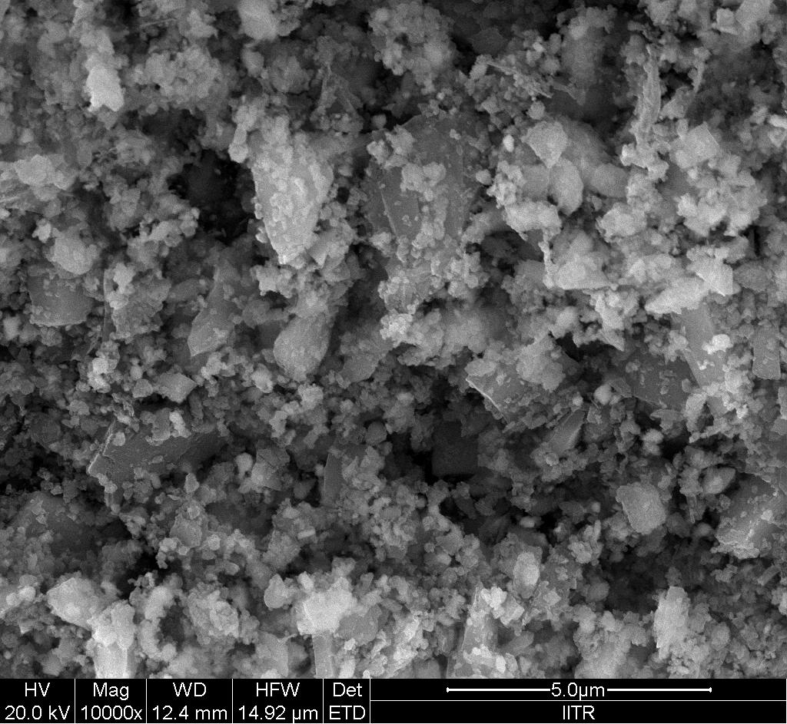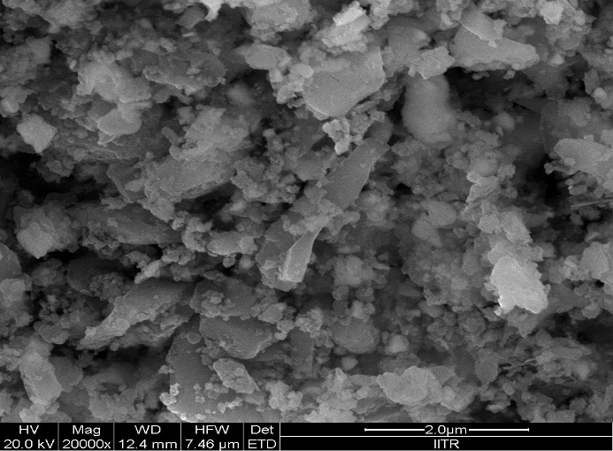

**Fig14: SEM images of Batch 2 sample,with normal etchant used.**

1. **EDS analysis:**

Light and dark colouration implies presence of different phases in the sample. Major phase-SiC, minor phases-TiCN (reinforcement) as well as SiO2 and other impurity compounds. How do we know that lighter phase is WC-TiCN?

Percentage of Ti,W from EDS data indicates that lighter grain regions are Ti-rich,W-rich BUT darker regions are Si-rich. Since Si is present as SiC, and W,Ti are present in their respective compound forms, we can make the following conclusions.

* Major elements present-C, Si, Ti, W .

Tungsten an impurity , added at milling stage .Present as WC percentage is sufficiently high so as to consider that it is now part of a composite of SiC-WC.

**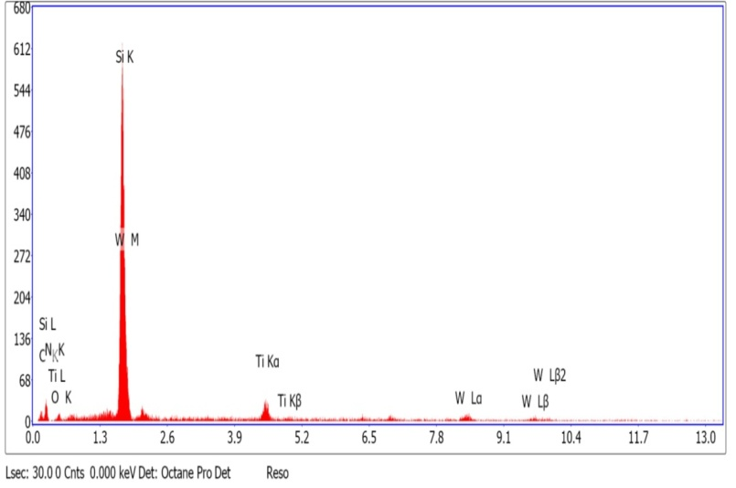**

**Figure 15:EDW plot for sample supporting**

Table 6:Elemental Composition by EDS

|  |  |  |  |  |
| --- | --- | --- | --- | --- |
| **EDS DATA- SiC with 10% TiCN** | | | | |
| Element | Weight% | Atomic% | Net int. | Error % |
| C K-line | 29.32 | 58.03 | 9.17 | 17.08 |
| N K-line | 0.14 | 0.24 | 0.03 | 99.99 |
| O K-line | 3.57 | 5.31 | 2.60 | 27.98 |
| Si K-line | 35.06 | 29.67 | 237.95 | 4.07 |
| Ti K-line | 9.15 | 3.55 | 21.14 | 15.21 |
| W L-line | 22.77 | 3.20 | 10.12 | 30.31 |

* **DENSITY CALCULATIONS:**

The density of the pellet formed during SPS was measured using Archimedes principle. The mass of the pellet were measured using electronic beam balance.

* Mass in air – 0.836 g
* Mass in Water – 0.634 g
* Experimental Density: (Ma)/ (Ma – Mw) \* ρw

=**4.2608 g/cc**

* **Again, accounting for theoretical density keeping presence of Tungsten compounds gives expected theoretical density=4.37 g/cc.**
* **%densification=97.5%**

**Batch 3: SiC-WC with 35% TiCN**

In this Batch had SiC dominantly in 1 phase-hexagonal or 6H, with only traces of others. TiCN was non-stoichiometric too, but reverse of Batch 2.C=0.3,N=0.7 indicating that larger amount of Ti+ ions had made C as limiting reagent during recombination and made N as larger faction.

**Also, Si 100% intensity peak came at 41.6°, unusual for Si but fully explained by fact that there is a solid solution of SiC-WC. This explains peak of W being at 41.7,100% intensity. The presence of solid solution is confirmed by similar hexagonal unit cell structure too.**

Small but not negligible amount of both W2C and W2N present. But it is so less, and intensity peaks indicate that we can ignore this.

**a)XRD Analysis:** We get The peak at 41.7°as mentioned from here, and confirmation of presence of various elements-Si,C,Ti,N,W.

TiCN peaks: 100% at 49.64°



Figure 16 : XRD profile indicating TiCN peaks

Si peaks: 100% at 41.7°

****

Figure 17 : XRD profile indicating SiC peaks

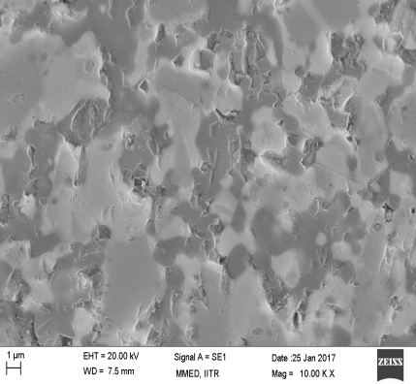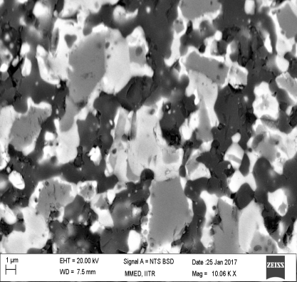**b)SEM Analysis:** Darker region is SiC rich, as is discussed in prior samples, and confirmed by taking spot EDS over darker and lighter regions. Lighter region is W-rich and Ti-rich, with higher % of Ti and W confirmed by peaks obtained in EDS. But there are some portions of sample, completely black, which are indicator of porosity in sample. Images taken are normal etched images.

Figure 18 (a) and 18(b):Microstructure of sample under normal etch.

**c)EDS spot analysis**:

We not only get confirmation of lighter and darker spots' composition in terms of present phases (similar to prior samples, darker phase is SiC rich portion), but peaks' overlap confirms presence of solid solution and shows the trend of WC-SiC solid solution(indicated by study of peaks too-Si overlap with W at ~ 41.6°).

On doing spot analysis of multiple sample regions, of which 1 each of darker and lighter region are covered here-Spectra 2 and 6 respectively.

Spectrum 2 :A darker region of sample was region marked Spectrum 2.Spot analysis of this region-darker portion of our sample- gives the following elemental composition.

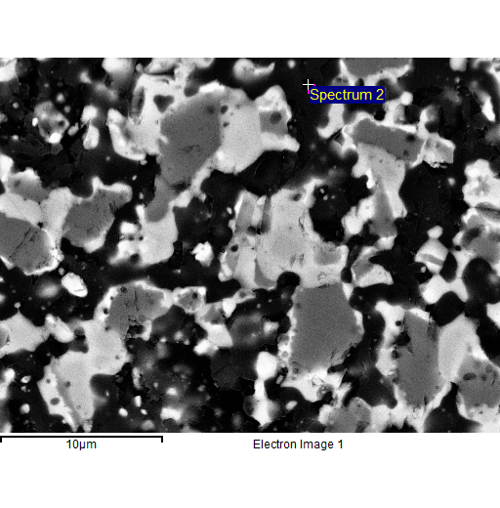

Table 7:Elemental Composition by EDS

|  |  |  |
| --- | --- | --- |
| Element | Weight% | Atomic% |
| C K | 24.60 | 46.28 |
| Si K | 56.25 | 45.26 |
| Ti K | 17.49 | 8.25 |
| W M | 1.66 | 0.21 |
| Total | 100 | 100 |

Figure 19:Spectrum for which EDS Spot analysis was done

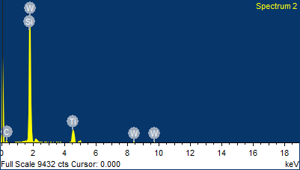

Figure 20:EDS Plot for Spectrum 2

The dominant peak of Si confirms this to be a SiC rich region(Si is present only in SiC compound form), while overlapping of the peaks of SiC-W indicates that solid solution is formed.Thus darker region is Si-rich.

Spectrum 6:This portion of our sample is lighter and gave the following set of results on spot analysis.This region is richer in Ti,as indicated by table we obtained on spot analysis. Noticing graph below,we see Ti peak is significantly higher than in graph for Spectrum 2.

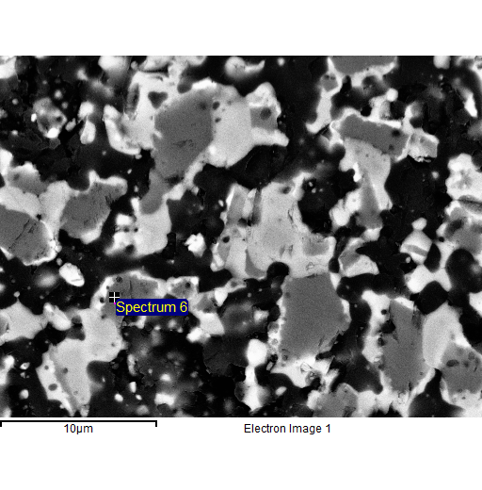

Table 8:Elemental Composition by EDS

|  |  |  |
| --- | --- | --- |
| **Element** | **Weight%** | **Atomic%** |
| C K | 11.38 | 32.56 |
| Si K | 21.8 | 26.67 |
| Ti K | 53.33 | 38.25 |
| W M | 13.49 | 2.52 |
| Total | 100 | 100 |

Figure 21:Spectrum for which EDS Spot analysis was done

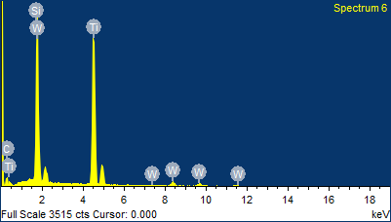

**Figure 22:EDS Spot Analysis profile of Spectrum 6**

**DENSITY CALCULATIONS:**

The density of the pellet formed during SPS was measured using Archimedes principle. The mass of the pellet were measured using electronic beam balance. As before, principle of mixtures was used, and stoichiometric mixing was accounted for before computing theoretical density.

**Results:**

**1) Densification = 98.4%**

**2) Theoretical density = 4.71 g/cc**

**3) Experimental value = 4.64 g/cc**

Batch 4:SiC-WC with 50% TiCN

6H SiC only dominant phase evolved, in case of SiC.  
The upper stick pattern is SiC, lower is WC. Overlap of 100% peaks of both at ~41.7° indicates that solid solution was formed in this case too.

We observe TiC and TiCN presence too, making this a SiC-WC-TiCN composite. EDS,XRD and SEM analyses were done here too.

a)XRD Analysis:On doing XRD analysis we got peaks as in previous 2 samples with additives.Here too,we see Si peaks at ~41.6 and TiCN at ~50.

SiC peaks:100% at 41.617



Figure 22:XRD Profile indicating SiC peaks

TiCN peaks:100% at 49.6



Figure 23:XRD Profile indicating TiCN peaks

**b) SEM Analysis:** On conducting SEM analysis we conclude darker portions to be SiC-rich,while lighter portions are rich in Ti compounds, with TiCN present as major source of Ti. Images taken are with normal etchant-KOH 50%/NaOH 50% 1M solution.

Completely black regions indicate porosity present in this sample too,and show that 100% densification was not achieved.

However , such regions are present in this sample the least, indicating that TiCN % increase helps in getting better densification.

C:\Users\Riddheish\Desktop\riddheish\SiC-50%TiCN sem images normal etched-20170305T164950Z-001\SiC-50_TiCN sem images normal etched\108.tif C:\Users\Riddheish\Desktop\riddheish\SiC-50%TiCN sem images normal etched-20170305T164950Z-001\SiC-50_TiCN sem images normal etched\106.tif

Fig 24 (a) and 24(b):SEM image of Microstructure of sample taken after normal etch

**c)EDS Analysis :** Spot analysis confirms composition of lighter and darker regions, and darker region is SiC rich, while lighter region is TiCN rich.

**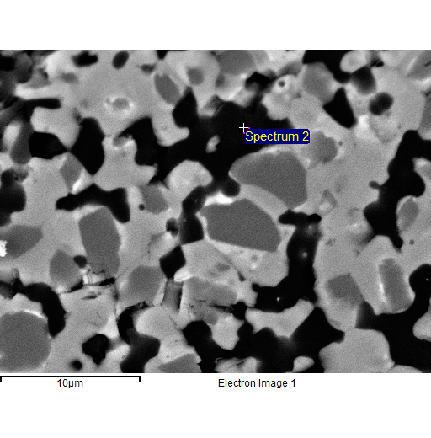**Spectrum 2 Spot analysis: This is a darker region of sample and on EDS analysis, we see SiC % higher in this region than in a lighter portion of the sample.

Table 8:Elemental Composition by EDS

|  |  |  |
| --- | --- | --- |
| **Element** | **Weight%** | **Atomic%** |
|  |  |  |
| C K | 36.98 | 61.24 |
| Si K | 41.56 | 29.43 |
| Ti K | 21.81 | 9.47 |
| W M | 1.35 | 0.15 |
|  |  |  |

Fig 25: Spectrum of EDS Spot analysis

The presence of solid solution of SiC-W is shown here from overlapping peaks of Si and W.

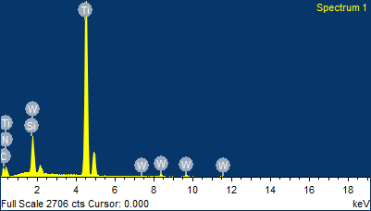

Figure 26:EDS Profile for Spectrum 1

Spectrum 1:Lighter region, as stated from SEM analysis, shows large % of Ti when compared to darker regions surrounding it.

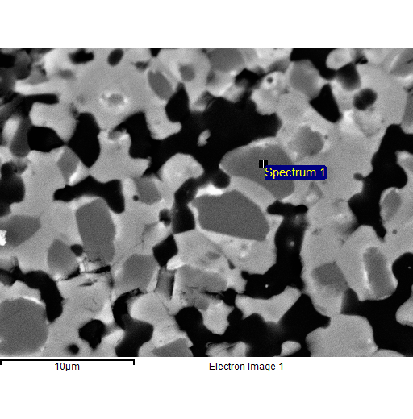

Table 9:Elemental Composition by EDS

|  |  |  |
| --- | --- | --- |
| Element | Weight% | Atomic% |
| C K | 8.98 | 26.09 |
| N K | 6.09 | 15.17 |
| Si K | 3.96 | 4.92 |
| Ti K | 71.37 | 52 |
| W M | 9.6 | 1.82 |
| Totals | 100 | 100 |
|  |  |  |

Fig 27: Spectrum of EDS Spot analysis

**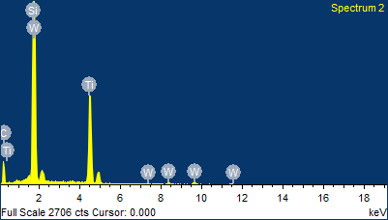**Ti peak is markedly higher than in spectrum 2(in fact highest of all elements here)this EDS graph,showing it to be Ti rich region.

**Figure 28:EDS Spot analysis profile for Spectrum 2**

**DENSITY CALCULATIONS:**

The density of the pellet formed during SPS was measured using Archimedes principle. The mass of the pellet were measured using electronic beam balance. As before, principle of mixtures was used, and stoichiometric mixing was accounted for before computing theoretical density.

Theoretical density=4.79 g/cc

Actual density=4.73252

% densification=98.9%

Best densification obtained in this sample.

**RESULTS**

1)Density evaluation-comparative table:

|  |  |  |  |  |  |  |
| --- | --- | --- | --- | --- | --- | --- |
| **Sr No** | **%SiC-W** | **% TiCN** | **Sintering conditions** | **Theoretical Density** | **Density obtained** | **% densification** |
|  |  |  |  |  |  |  |
| 1 | 100 | 0 | Temp:1800°C Pressure:50 MPa | 4.33 | 4.21 | 97.2 |
| 2 | 90 | 10 | Temp:1800°C Pressure:50 MPa | 4.37 | 4.26 | 97.5 |
| 3 | 65 | 35 | Temp:1800°C Pressure:50 MPa | 4.71 | 4.64 | 98.4 |
| 4 | 50 | 50 | Temp:1800°C Pressure:50 MPa | 4.79 | 4.74 | 98.9 |

Density of SiC is less than that of TiCN or Tungsten, so density obtained on adding TiCN in larger % is expected to be more and this is what was seen.

Densification %age is not expected to be 100% but closer to 100% is desirable.We noted that as % TiCN increased, % densification increased too.This proves that TiCN is a very favourable additive for SPS in case of TiCN.

2)Mechanical testing values of samples:

Testing conditions:

* Diamond – Berkovich Tip- 3 face Pyramid with Tip Radius 100 nm.
* Normal Load Applied- 5000µN
* Loading cycle
* - constant loading and unloading rate of 62.5µN/ s,93.75 µN/s, 125µN/s
* -Dwell at a peak load- 2s.

|  |  |  |  |  |
| --- | --- | --- | --- | --- |
| **Sample** | **Contact Depth in nm** | **Modulus of elasticity in GPa** | **Hardness in GPa** | **Mean/Std. Deviation** |
| SiC monolithic | 81.53 | 326.79 | 22.21 | Mean |
|  | 13.05 | 37.85 | 5.71 | Std Deviation |
| SiC-W + 10% TiCN | 56.58 | 368.3 | 41 | Mean |
|  | 4 | 49.32 | 5.39 | Std Deviation |
| SiC-W + 35% TiCN | 63.32 | 330.47 | 33.67 | Mean |
|  | 13.31 | 41.32 | 9.01 | Std Deviation |
| SiC-W + 50% TiCN | 55.26 | 386.87 | 42.65 | Mean |
|  | 3.64 | 14.5 | 5.04 | Std Deviation |

**CONCLUSION**

1)Density variation occurs with % increase in TiCN, when compared to expected theoretical values computed from principle of mixtures. When comparing across varied sample % ages, we notice that as relative density increases,increased presence of 6-H phase is also seen, indicating it to be a cause. Also, improvement seen in mechanical properties with this presence.

**2)Presence of 6-H phases has direct relationship with % TiCN as additive-more the TiCN,more the conversion from β-SiC to 6-H α-SiC.**

3)β to α-SiC transformation indicated to occur during densification process. The change is partial, with large % of cubic β-SiC unchanged. Presence of semi-solid phase inferred from here as there is partial β-to-α transition.

4) α-SiC is present in larger %age as we move from monolithic SiC to samples with increasing %age of TiCN. This in turn makes structure more hexagonal. Also, beyond a threshold, for 35% and 50% TiCN samples, the SiC forms a solid solution with W that got added in during milling stage.

5)Microstructure has lesser porosity present as TiCN increases. This indicates that TiCN is a very effective additive for SPS of SiC based composites, provided we want α-SiC to be the dominant SiC phase.

6)Adding TiCN as additive bettered the hardness of post-sintered composite.

**BIBLIOGRAPHY**

[1] T. Narushima, T. Goto, T. Hirai and Y. Iguchi, Mater. Trans. JIM, 38, 821–835 (1997).

[2] K.S. Chan and R.A. Page, J. Am. Ceram. Soc., 76, 803–826 (1993).

[3] P.M. Sargent and M.F. Ashby, Scripta Metall., 17, 951–957 (1983).

[4] J.E. Lane, C.H. Carter and R.F. Davis, J. Am. Ceram. Soc., 71, 281–295 (1988).

[5] S.G. Cook, J.A. Little and J.E. King, Br. Corros. J., 29, 183–189 (1994).

[6] S. Prochazka, P. Popper, Special Ceramics, vol. 6, British Ceramic Research Association, Stoke-on-Trent, England, (1975) pp. 171–182.

[7] C. Greskovich and J.H. Rosolowski, J. Am. Ceram. Soc., 59, 336–343 (1976).

[8] T. Hase and H. Suzuki, J. Ceram. Soc. Jpn., 88, 258–264 (1980) [in Japanese].

[9] R.J. Hannink, Y. Bando, H. Tanaka and Y. Inomata, J. Mater. Sci., 23, 2093–2101 (1988).

[10] P. Elder and V.D. Krstic, Br. Ceram. Trans. J., 91, 67–71 (1992)

[11] Silicon Carbide. Structure, Properties and Processing- V. A. Izhevskyi1, L. A. Genova, J. C. Bressiani, A. H. A. Bressiani.  Instituto de Pesquisas Energeticas e Nucleares, C. P. 11049, Pinheiros, 05422-970, S. Paulo, SP, Brazil

[12] Kun Mo Kim, Seung Hoon Jang, Young-Wook Kim and Won-Seon Seo

Functional Ceramics Laboratory, Department of Materials Science and Engineering, The

University of Seoul,Seoul 130-743, Korea Energy and Environmental Division, Korea Institute of Ceramic Engineering and Technology, Seoul 153-801, Korea

[13]H. ENDO, M. UEKI, H. KUBO R and D Laboratories-I, Nippon Steel Corporation, 1618 Ida, Nakahara-ku, Kawasaki 211, Japan

[14] K. Niihara, A. Nakahira, T. Uchiyama, T. Hirai, in: A.G. Evens,R.C. Brandt, F.F. Lange, P.H. Hasselman (Eds.), Fracture Mechanics of Ceramics, Vol. 7, Plenum Press, New York, 1986, pp. 103–

[15] V. Yaroshenkoa) and D.S. Wilkinson,Department of Materials Science and Engineering, McMaster University, 1280 Main Street West,Hamilton, Ontario L8S 4L7, Canada(Received 28 April 1999; accepted 13 March 2000)

[16]Y. Liu, Y.-Y. Wang, G.-J. Yang, J.-J. Feng, and K. Kusumoto,“Effect of Nano-Sized TiN Additions on the Electrical Properties of Vacuum Cold Sprayed SiC Coatings,” J. Thermal. Spray. Technol., 19, 1238–43(2010).

[17] K. J. Kim, K. M. Kim, and Y.-W. Kim, “Highly Conductive SiC Ceramics Containing Ti2CN,” J. Eur. Ceram. Soc., 34, 1149–54 (2014).

[18]X. Guo, H. Yang, X. Zhu, and L. Zhang, “Preparation and Properties of Nano-SiC-Based Ceramic Composites Containing Nano-TiN,” Scripta Mater.,68, 281–4 (2013).

[19] X. Guo, H. Yang, L. Zhang, and X. Zhu, “Sintering Behavior, Microstructure and Mechanical Properties of Silicon Carbide Ceramics Containing Different Nano-TiN Additive,” Ceram. Int., 36, 161–5 (2010).

[20] J. Lao, N. Shao, F. Mei, G. Li, and M. Gu, “Mutual Promotion Effect of Crystal Growth in TiN/SiC Nanomultilayers,” Appl. Phys. Lett(2005).